Episode 540: Quarks and the standard model

The quark model, justified by the results of deep inelastic electron scattering, creates relative order out of the chaos of particle classification.
Lesson Summary
- Discussion: Rules for quarks (15 minutes)
- Student activity: Making non-strange hadrons with quark triangles (15 minutes)
- Student questions: Making strange hadrons with quark triangles (15 minutes)
- Discussion: Gluons and the force between quarks (15 minutes)
- Student activity: Constructing Feynman diagrams (20 minutes)
- Discussion: Summing up (10 minutes)
Quarks have three colour charges, and the rule for stability is that combinations must be colourless.

Discussion: Rules for quarks
Students need to be informed of the rules for combining quarks.
Where the electromagnetic interaction is due to the property of electric charge, which can be positive or negative, quark interaction is due to a property which can have three different states. This has been called colour charge, because the three primary colours red, green and blue add to give white, a colourless combination. These three-quark combinations are the baryons.
Anti-quarks have an anti-colour; you may wish to think of the complementary colours to the three primary colours, so anti-red is cyan, anti-green is magenta and anti-blue is yellow. Three anti-quark combinations are the anti-baryons.
By combining a quark with an anti-quark of the appropriate anti-colour, a two-quark hadron can be produced. These two-quark combinations are the mesons.

Student activity: Making non-strange hadrons with quark triangles
The quark triangle are constructed so that they can be fitted together in threes, with the 120° vertices together, with the combination red, blue and green giving a baryon. A similar arrangement with anti-red, anti-blue and anti-green gives an anti-baryon. By taking one quark and fitting an anti-quark of the appropriate anti-colour alongside it so that the two long sides coincide, a meson can be constructed.
Episode 540-1: Quark triangles (Word, 121 KB) - see end of document

Episode 540-2: Quark models (Word, 36 KB) - see end of document

The document contains two versions of each anti-quark: one version uses the same colours as the related quarks, but with the white and coloured regions of the triangles reversed. The second version has the same pattern of colours on the triangles as the related quarks, but the complementary colours are used instead of red, blue and green: thus anti-red is cyan, anti-blue is yellow and anti-green is magenta. You can choose whichever form you prefer!
Using only u (+2e/3) and d quarks (-1 e/3) and their anti-quarks, u bar and d bar, in all possible colours, students can quickly use the three-colour rule to construct four possible baryons
(n, p and the unstable Δ ⁻ and Δ ⁺⁺ ) together with their anti-particles. Other non-strange baryons are high energy states of these four, e.g. the Δ ⁺ and Δ ⁰ particles are uud and udd respectively, and can decay to the proton and neutron by emitting the extra energy as a gamma photon
Δ ⁺ → p + γ
Δ ⁰ → n + γ
They should also be able to construct four different mesons, all pions. Two of these are, in fact, the same particle (u + u bar and d + d bar, both π⁰).
Issue the strange quarks, s and s bar, at this point, with the explanation that they are heavier versions of d and d bar, and that they have strangeness of -1 and +1 respectively. This allows the construction of all the particles in the baryons decuplet and meson octet.

Student questions: Gluons and the force between quarks
These questions use the u and d quark triangles and their anti-quark triangles.
Episode 540-3: Putting quarks together (Word, 56 KB) - see end of document

Further questions take a similar approach to explain the baryon decuplet and meson octet. These questions can be used to structure the student activity, or else as homework to consolidate the learning afterwards.
Episode 540-4: Strange quarks (Word, 45 KB) - see end of document

Discussion: Gluons and the force between quarks
Just as pions (Yukawa’s mesons) are the particles that bind baryons, the quarks in a baryon are bound by exchanging a particle. The particles here are gluons , and we envisage the transfer as exchanging the colour of the two quarks concerned: e.g. a red quark will change into a blue quark by emitting a red-antiblue gluon, which is then absorbed by a blue quark that becomes red.

Student activity: Constructing Feynman diagrams
If your specification requires it, the Feynman diagrams used for the weak interaction can now be extended to the strong interaction, and the n and p of the weak interactions replaced by d and u quarks respectively.
Episode 540-5: Feynman diagrams with quarks (Word, 99 KB) - see end of document

Discussion: Summing up
This is a conclusion to the entire particle physics sequence. It should be realised that normal matter we see around us consists of two quarks and two leptons, and their anti-particles. Larger mass versions, which are not stable, occur in two generations. The muon and strange quark have already been met, and, together with the muon neutrino and the heavier version of the u quark, the charm quark (c), form the second generation. There is only one more generation, so all matter, whether stable or not, can be described in terms of 6 quarks and 6 leptons.
Episode 540- 1: Quark triangles

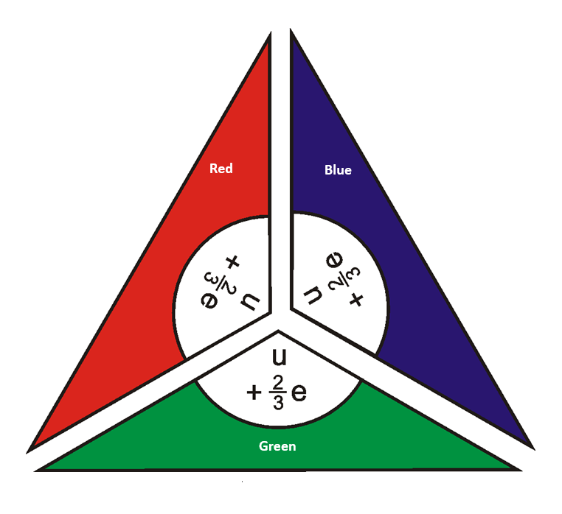
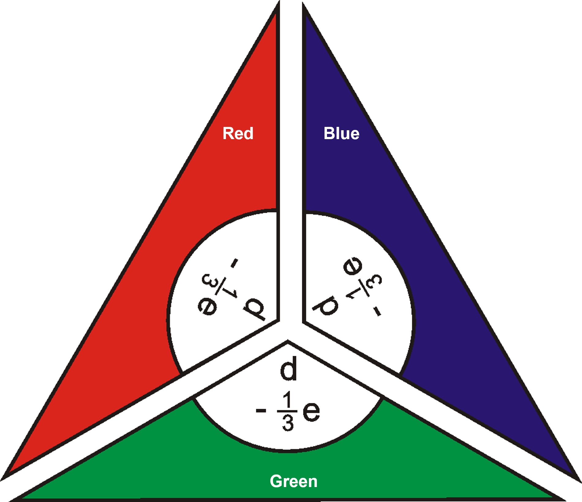
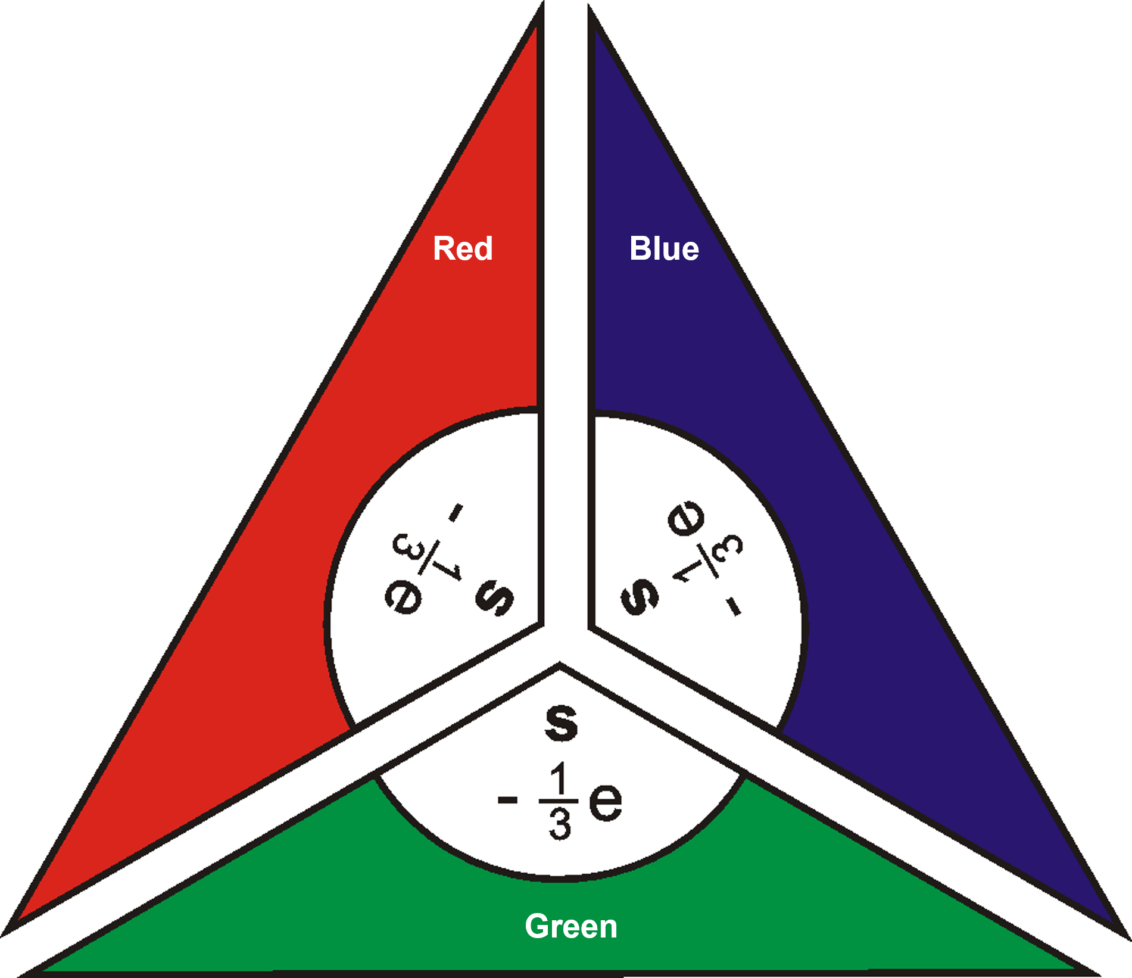
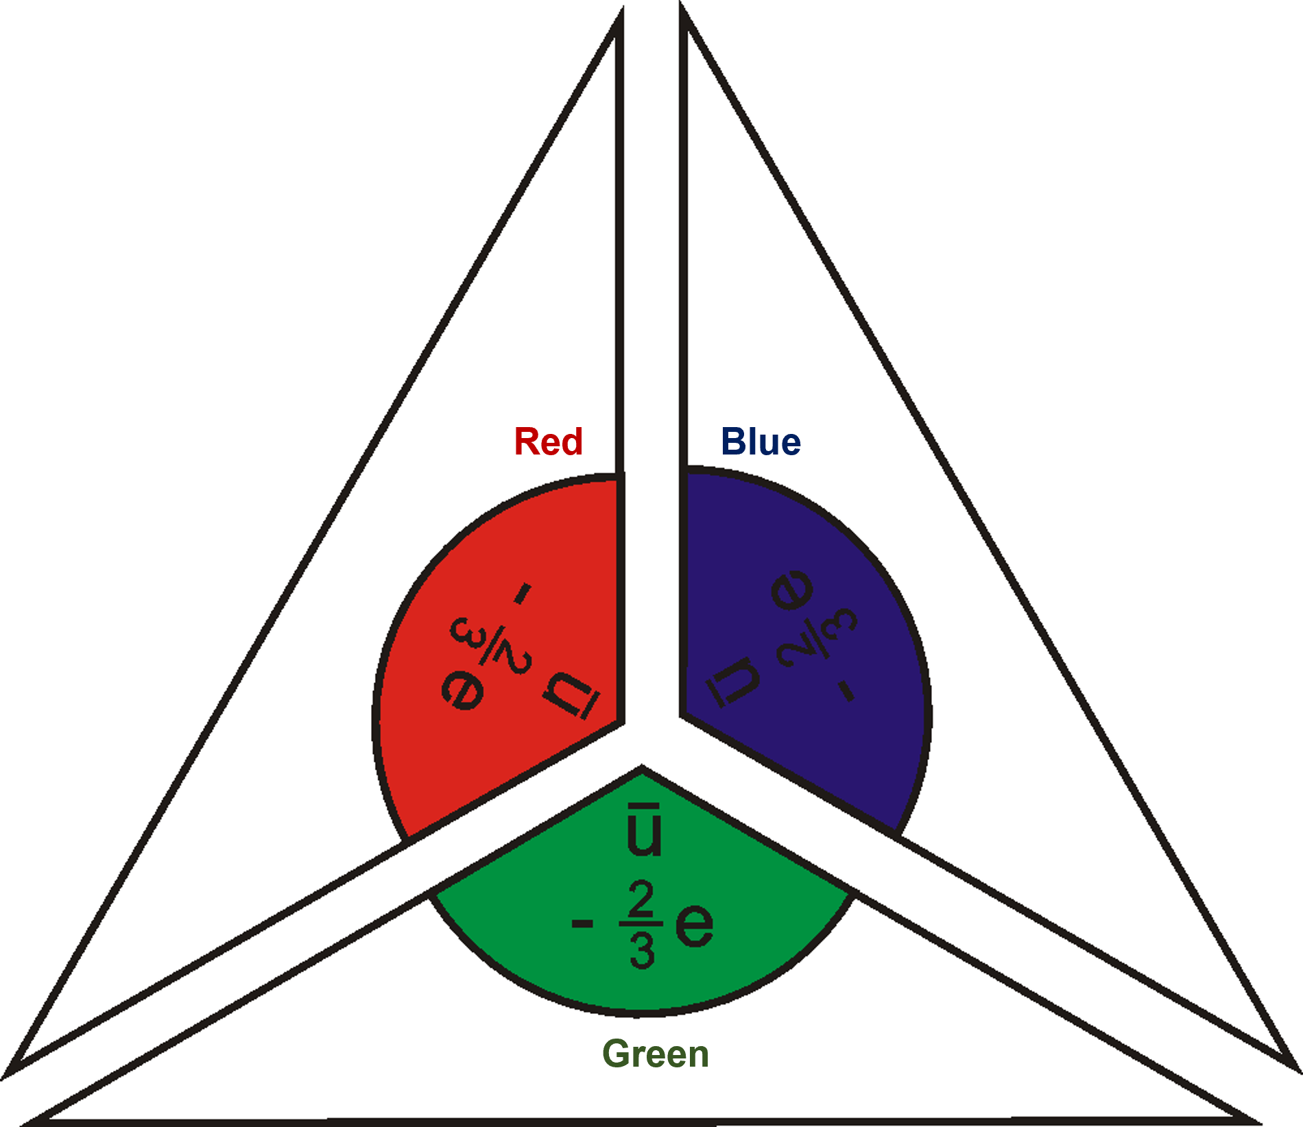
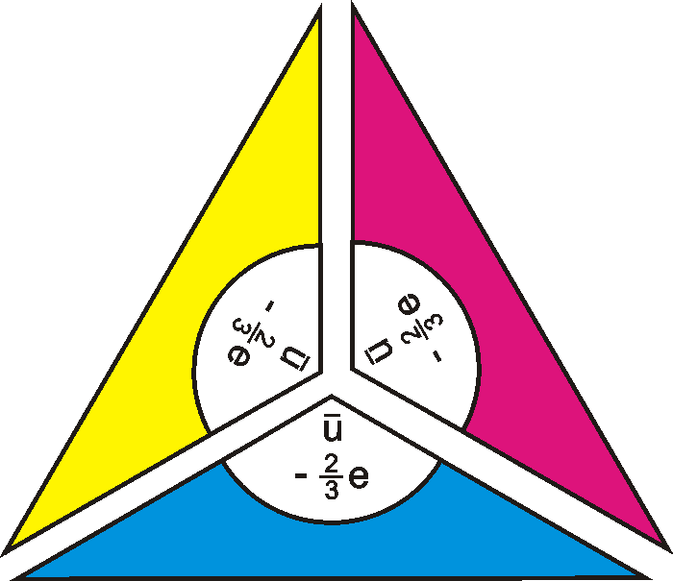
Yellow
Magenta
Cyan
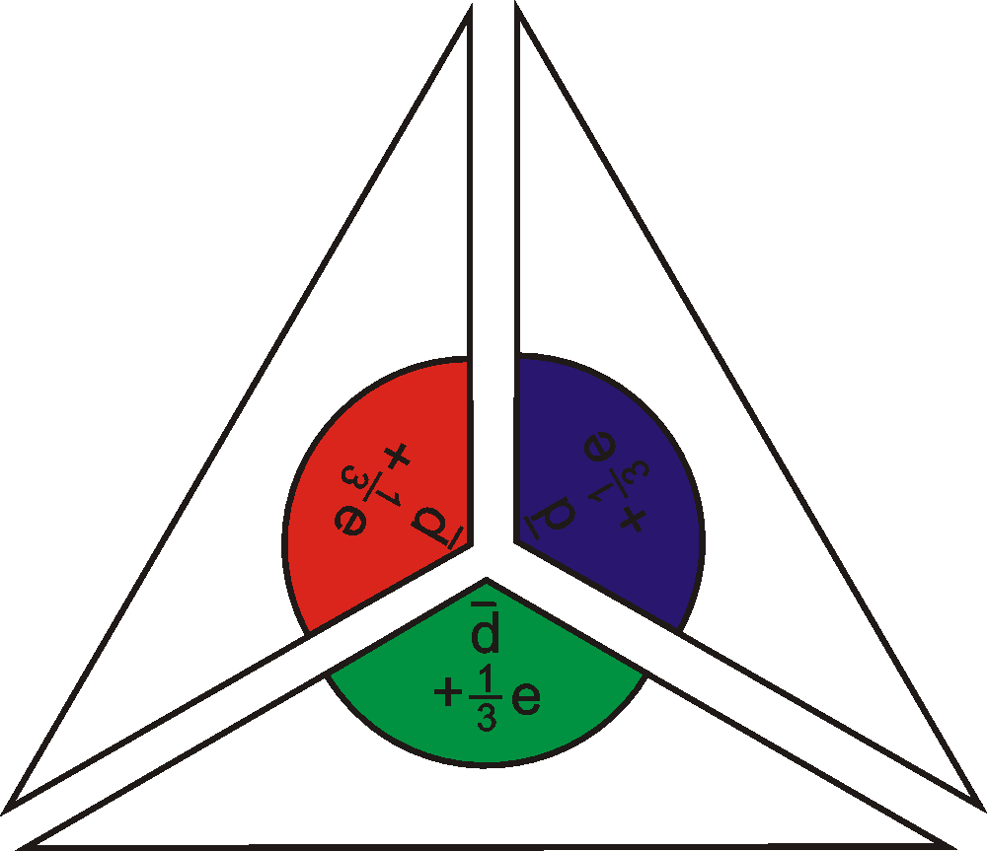
Blue
Red
Green
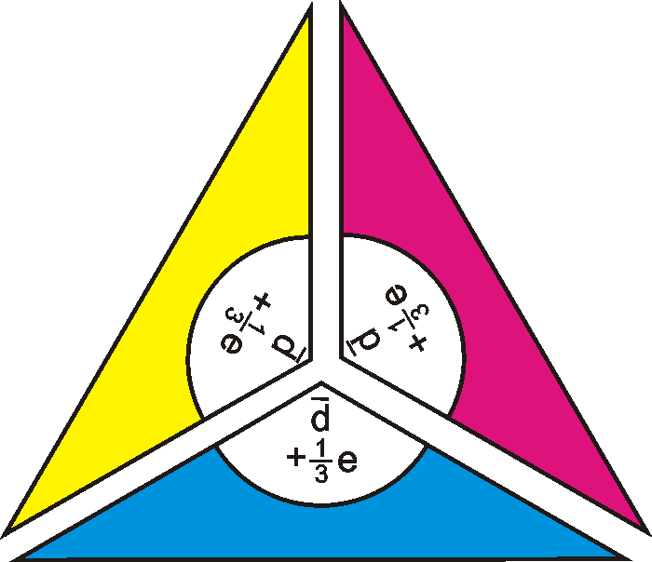
Yellow
Magenta
Cyan
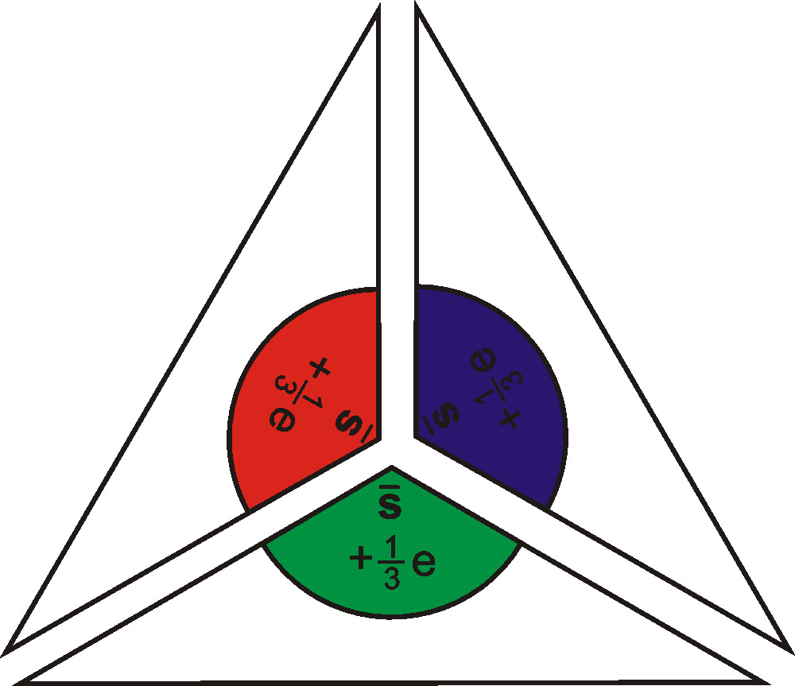
Blue
Red
Green
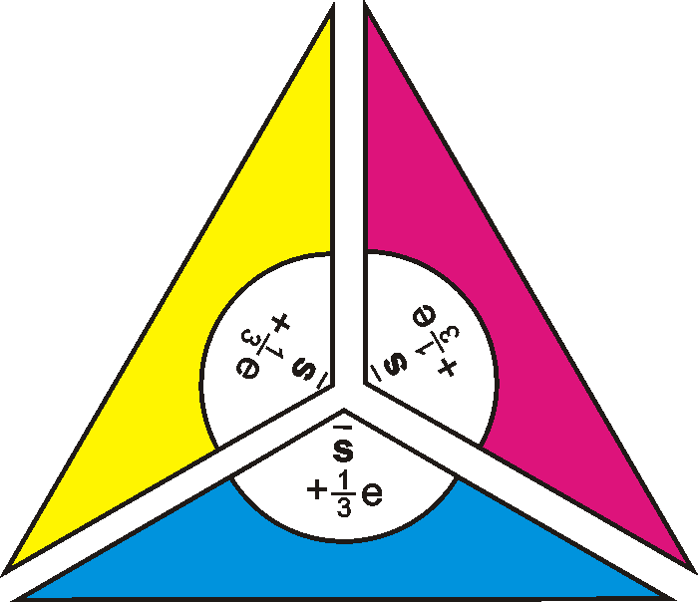
Yellow
Magenta
Cyan

External reference
This activity is taken from Advancing Physics chapter 17, 60P

Episode 540- 2: Quark models

Hadrons and quarks
This simple physical model allows construction of baryons (hadrons containing three quarks) using the basic up (u) and down (d) quarks or antiquarks (the same letters with bars above them – here called ubar or dbar quarks) to form equilateral triangles containing red, green and blue. The antiquarks have the same colours in opposite arrangement on the models. Quarks and antiquarks can combine to give mesons (hadrons containing two quarks). Quarks aren’t really 'coloured' of course. But each has a property that is an analogue of colour with a rule that says that to make a valid particle these properties must combine to give a colourless (white) result. No one can see these colours – or even investigate the properties of single quarks because they can’t exist on their own. The colours have to be worked out 'backwards' – from seeing what combinations actually exist in nature to make hadrons.
Historically, the names baryons, mesons and leptons are descriptions of observed particles in terms of their masses. Baryons are heavy, leptons are light, and mesons are in-between. It was later realised that leptons (electrons and neutrinos) were fundamental particles, while both baryons and mesons were combinations of smaller particles — quarks. This led to the introduction of the term hadrons (‘dense particles’) for both baryons and mesons.

You need
- Triangular models of the six possible u and d quarks and their six possible antiquarks. Each triangle labels the quark (u or d), whether it is a quark or an antiquark, gives its charge and its colour.

Rules of the game: building up hadrons from quarks
When quarks combine to form stable matter they have to satisfy two basic conditions:
- the net electric charge must be zero or a whole number of the electronic charge e;
- the final colour must be 'white'

Physicists knew that three primary colours make white: red, blue and green. Each of the primary colours has it complementary colour, which when added also makes white: yellow and blue make white because yellow is a combination of red and green. Yellow is sometimes called antiblue for this reason. The other two complementary colours are magenta (antigreen) and cyan (antired). This means that to make a stable combination of quarks we have one of three possibilities.
1. Three quarks of different primary colours, one red, one blue and one green.
2. Three antiquarks of different complementary colours, one antired, one antiblue and one antigreen. (The antiquarks each have a bar above the letter u or d)
3. A quark and an antiquark of the primary colour and its complement: e.g. red and antired.
The three-quark and three-antiquark combinations each form triangles with circles at their centres. The quark–antiquark combinations are made by placing the long edges together.

What to do
1. Produce three-quark combinations (baryons) with charge 0 (a neutron) and with charge +e (a proton).
2. What are the charges of the antiparticles to these two baryons?
3. Are there any other different combinations of three quarks? What is the resulting charge of each hadron?
4. Now produce quark–antiquark combinations (mesons) with charge 0, +e and –e.
5. Can you make or think of any other different combinations of quark and antiquark that make viable hadrons? Do they actually exist – or have they been discovered in experiment?

You have seen that
1. Deep inelastic scattering experiments showed that the proton and neutron have a sub- structure – they are made of smaller particles. With this simple model it can be seen that different combinations of two quark ‘building blocks,’ with charges of +2/3 e and –1/3 e, give the expected proton and neutron.
2. The quark–antiquark combinations give the pions (π -mesons). Two of the possible combinations give the neutral π⁰, while the other two combinations give the π ⁺ and π – particles.
3. Other combinations of three quarks are possible: the ddd combination, with charge –e and uuu with charge +2e are predicted. These particles are the unstable Δ⁻ and Δ⁺⁺.

Practical advice
The six possible u and d quarks and their six possible antiquarks are best printed on card and laminated.
Teachers may choose between two versions of the antiquarks: in one, each antiquark has the same colours as the quark but in the opposite sections of the triangle, whereas in the other, the same section is coloured but with the complementary colour, cyan for red, magenta for green, and yellow for blue.
These could be backed if wished (each antiquark on the reverse of its quark), which does emphasise their complementary nature, but it will restrict the production of mesons, so extra sets will be needed. Note that there is a choice of two antiquark styles as detailed in the requirements section above. Have handy a table of discovered particles so that students may check what it is they have constructed.
Although this model can readily be extended to strange and charmed hadrons, this is likely to extend it beyond its value, and to give undue emphasis to a ‘stamp-collecting’ approach to particle physics. A more useful extension could be to explain the creation of pions in high energy interactions via the creation (ΔE = Δmc²) of quark–antiquark pairs, e.g. in the decay Δ⁺⁺ → p + π⁺ where (u+u+u) becomes (u+u+d) + (dbar+u). This would involve starting with a hadron, and adding an extra (quark + its antiquark) pair to make new combinations using the colour combination rules.

External resources
Useful additional information can be gleaned from PPARC materials.
http://www.pparc.ac.uk/

Frank Close 1983 The Cosmic Onion (London: Heinemann)

External reference
This activity is taken from Advancing Physics chapter 17, 60P

Episode 540- 3: Putting quarks together

Three quarks for Muster Mark
The American physicist Murray Gell-Mann gave the name ‘quarks’ to the particles he proposed as the basic building bricks of other particles. The name refers to a line in the novel Finnegans Wake by James Joyce, who was famed for his word play. The line is: ‘Three quarks for Muster Mark’. His colleague George Zwieg wanted to call the particles ‘aces’, but Gell-Mann’s choice won out. In spite of the rhyme suggested by Joyce’s line, the word ‘quark’ is generally pronounced ‘quork’. The word is also German slang for ‘nonsense’ and the trade name for a type of yoghurt!

These questions ask about how quarks go together to make other particles.

Two kinds of quark
The simplest particles, including all the ones that everyday matter is made of, are built from two kinds (‘flavours’) of quark: ‘up’ and ‘down’. The most peculiar thing about them is that their electric charges come in multiples of 1/3 of the charge on an electron. On a scale where the charge on an electron is –1e, with e = 1.6 × 10–19 C, the charges on the quarks are:
- Up quark u: charge + 2/3 e.
- Down quark d: charge – 1/3 e.

Making massive particles
Relatively massive particles like the proton and neutron are made of combinations of three quarks.
1. What is the charge on the combination uuu?

2. What is the charge on the combination uud?

3. What is the charge on the combination udd?

4. What is the charge on the combination ddd?

There are four compound particles here.
5. Which combination has the right charge to be a proton?

6. Which combination has the right charge to be a neutron?

7. There is a particle called the Δ– which has a charge of –1e. Which quark combination could be the Δ–?

8. There is a particle called the Δ++ which has a charge of + 2e. Which quark combination could be the Δ–?

9. A neutron can be changed to a proton if one quark changes ‘flavour’. What change is needed? What charge must be carried away if this happens?

Making mesons
Other, lighter ‘middle-weight’ particles called mesons can be made from pairs of quarks. But they have to be made from a special combination: a quark and an antiquark. There are now four particles to play with:
- Up quark u: charge +2/3 e
- Down quark d: charge –1/3 e.
- Antiup quark $\overline{u}$ : charge –2/3 e.
- Antidown quark$\overline{u}$: charge + 1/3 e.
10. What is the charge on the combination u$\overline{u}$?

11. What is the charge on the combination d$\overline{d}$?

12. What is the charge on the combination u$\overline{d}$?

13. What is the charge on the combination d$\overline{u}$?

14. Which combination could be the π+ meson?

15. Which combination could be the π– meson?

16. Which could be the neutral π0 meson?

Practical advice
These practice questions run through the various quark combinations, and the quark–antiquark combinations. They are intended to help students get familiar with how the combinations work, so that only integer multiples of the electronic charge appear.

Alternative approaches
Perhaps a game with cards could be devised?

Social and human context
It was extremely difficult for physicists to accept that there could be fractional charges. The origin of the number 3 in particle physics (number of colours, number of generations) is still far from clear.

Answers and worked solutions

1. uuu has charge
$$+\frac{2}{3}e+\frac{2}{3}e+\frac{2}{3}e\text{=+}2e\text{.}$$
2. uud has charge
$$=\frac{2}{3}e+\frac{2}{3}e−\frac{1}{3}e\text{=+}1e\text{.}$$
3. udd has charge
$$=\frac{2}{3}e−\frac{1}{3}e−\frac{1}{3}e=0\text{.}$$
4. ddd has charge
$$−\frac{1}{3}e−\frac{1}{3}e−\frac{1}{3}e=−1e\text{.}$$
5. Proton has charge +1e so could be uud.
6. Neutron has charge 0 so could be udd.
7. Δ– has charge –1e so could be ddd.
8. Δ++ has charge +2e so could be uuu.
9. A down quark, charge –1/3 e changes to an up quark, charge +2/3 e, so the charge carried away must be –1 e if charge is to be conserved.
10. u$\overline{u}$ has charge +2/3 e –2/3 e = 0.
11. d$\overline{d}$ has charge –1/3 e + 1/3 e = 0.
12. u$\overline{d}$ has charge +2/3 e + 1/3 e = 1e.
13. d$\overline{u}$ has charge –1/3 e – 2/3 e = –1e.
14. The π+ with charge + 1e could be u$\overline{d}$.
15. The π– with charge – 1e could be d$\overline{u}$.
16. The neutral π0 could be either or both of u$\overline{u}$ and d$\overline{d}$. In fact it is an equal mixture of the two.

External reference
This activity is taken from Advancing Physics chapter 17, 110S

Episode 540- 4: Strange quarks

An early classification of strange baryons by Murray Gell-Mann and Yuval Ne’emen gave this arrangement, called the baryon decuplet. The diagonal rows show baryons of the same charge. The Δ⁰ and Δ⁺ particles are more massive versions of the neutron and proton respectively

Δ⁻ |  | Δ⁰ |  | Δ⁺ |  | Δ⁺⁺ | strangeness 0
 | Σ⁻ |  | Σ⁰ |  | Σ⁺ |  | strangeness -1
 |  | Ξ⁻ |  | Ξ⁰ |  |  | strangeness -2
 |  |  | Ω⁻ |  |  |  | strangeness -3

The Ω⁻ was, in fact, predicted by Gell-mann from a gap in this pattern in much the same way as Mendeleyev predicted missing elements from gaps in his table. The subsequent discovery of the Ω⁻ confirmed that particle physicists were on the right track with this classification, which led Gell-mann and Zweig to the quark theory.

The strange quark s is a more massive version of the down quark d, and has the same charge (-e/3).

The presence of a strange quark gives a baryon or meson a strangeness of -1.
1. The Δ⁰ and Δ⁺ particles are more massive versions of the neutron and proton respectively. Underneath each particle in the first row, write the three quarks that make up that baryon.
2. The strange quark s is a more massive version of the down quark d, and has the same charge (-e/3). How many strange quarks must there be in
(a) the Σ particles?

(b) the Ξ particles?

(c) the Ω⁻ particle?

3. Write under all the strange baryons the three quarks they must contain.

The strange mesons fit a similar pattern:

 | K ⁰ |  | K⁺ |  | strangeness +1
π⁻ |  | π⁰ |  | π⁺ | strangeness 0
 | K ⁻ |  | K ⁰ |  | strangeness -1

4. If the strange quark s has a strangeness of -1, what is the strangeness of its anti-quark, s-bar?

5. Each of these seven mesons consists of a u, d or s quark and a u-bar, d-bar or s-bar antiquark. Write down under each meson the quark and antiquark it contains.

Answers and worked solutions
An early classification of strange baryons by Murray Gell-Mann and Yuval Ne’emen gave this arrangement, called the baryon decuplet. The diagonal rows show baryons of the same charge. The Δ⁰ and Δ⁺ particles are more massive versions of the neutron and proton respectively.
1. and 3.

Δ⁻  ddd |  | Δ⁰  udd |  | Δ⁺  uud |  | Δ⁺⁺  uuu | strangeness 0
 | Σ⁻  dds |  | Σ⁰  uds |  | Σ⁺  uus |  | strangeness -1
 |  | Ξ⁻  dss |  | Ξ⁰  uss |  |  | strangeness -2
 |  |  | Ω⁻  sss |  |  |  | strangeness -3

2.
(a) 1
(b) 2
(c) 3
4. +1
5.

 | K⁰  d s-bar |  | K⁺  u s-bar |  | strangeness +1
π ⁻  d u-bar |  | π⁰  d d-bar  u u-bar  s-sbar |  | π⁺  u d-bar | strangeness 0
 | K –  s u-bar |  | K ⁰  s d-bar |  | strangeness -1

Episode 540-5: Feynman diagrams with quarks

Feynman diagrams can be used for strong interactions as well as weak and electromagnetic interactions.

Quarks interact by the exchange of bosons called gluons. On Feynman diagrams, these are shown by curly lines. When a quark emits a gluon, it changes colour, and the quark absorbing it changes colour in the opposite way.

Thus a red quark can change into a blue quark by emitting a red - anti-blue gluon. When a blue quark absorbs the red - anti-blue gluon, it turns into a red quark.

Use the quark and gluon cards to construct Feynman diagrams for the interactions binding quarks together in baryons.
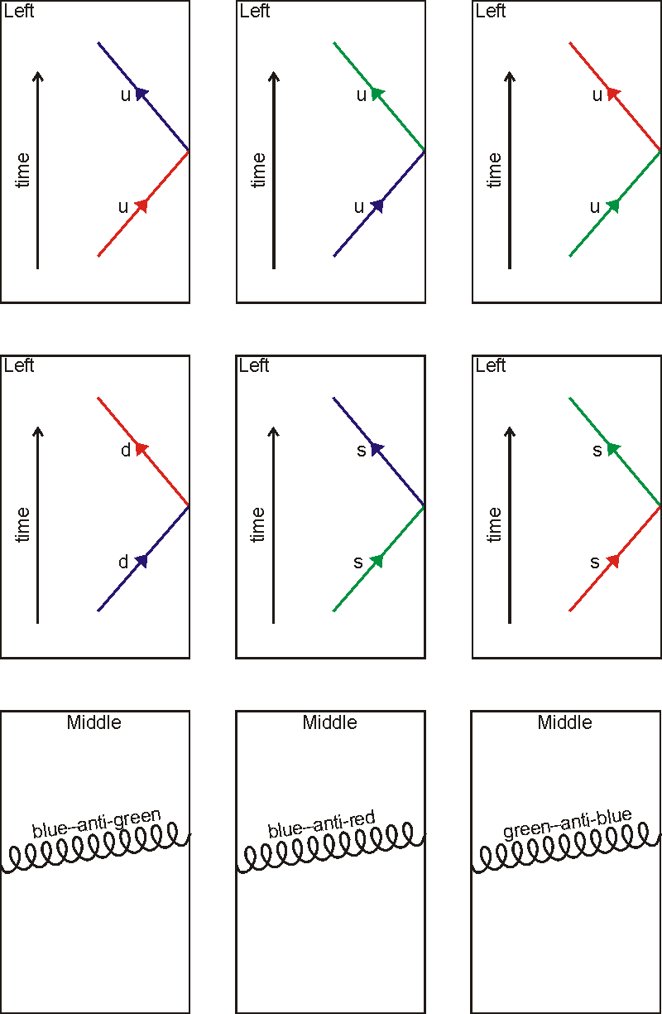
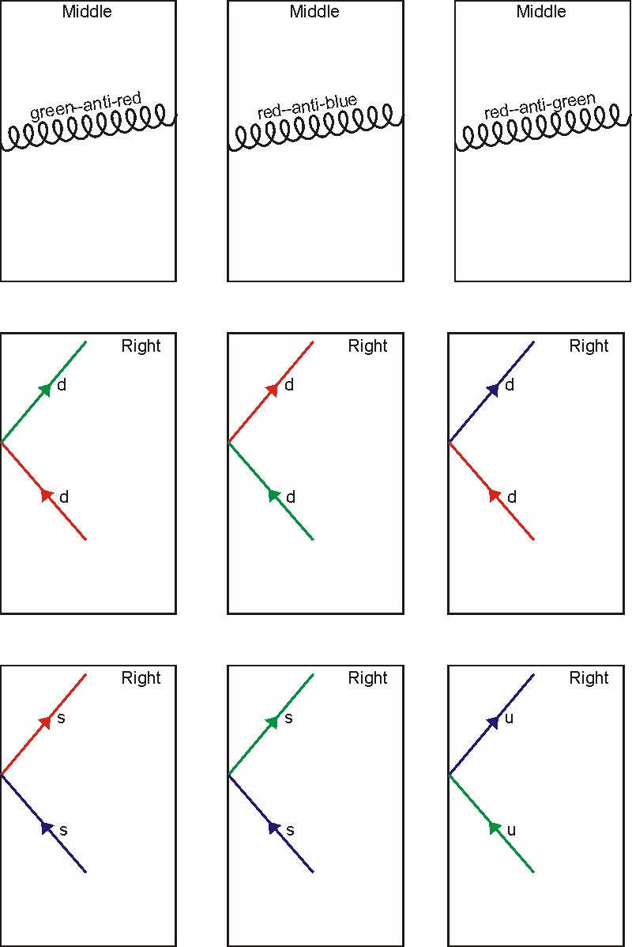

Answers and worked solutions

Feynman quark solutions
The key point is that, taking this first solution as an example, a red-antiblue gluon carries the colours red and antiblue, so on leaving a red quark it carries away the red colour and leaves the absence of antiblue, i.e. blue, so the red quark it has left become blue. When it reaches a blue quark, the antiblueness of the gluon cancels the blueness and the redness of the gluon makes the target quark red.

